Las tareas en trabajo y en casa: revise this vocab for a test next week

- I tend to = suelo + infinitive
- I usually = suelo + infinitive
- I have to = tengo que + infinitive

- To help passengers = ayudar a los pasajeros
- To help at home = ayudar en casa
- to cook = cocinar
- to answer the phone = contestar el teléfono
- to cut customers’ hair = cortar el pelo a los clientes
- to look after the patients = cuidar a los pacientes
- to look after gardens = cuidar los jardines
- to babysit = hacer de canguro
- to wash the car = lavar el coche
- to wash the dishes = lavar los platos
- to clean rooms limpiar habitaciones
- to do the vacuuming = pasar la aspiradora
- to walk the dog = pasear al perro
- to iron the clothes = planchar la ropa
- lay the table = poner la mesa
- to prepare different dishes = preparar platos distintos
- to clear the table = quitar la mesa
- to repair cars = reparar coches
- to deliver newspapers = repartir periódicos
- to serve food and drink = servir comida y bebida
- to work with animals = trabajar con animales
- to work with children = trabajar con niños
- to sell clothes = vender ropa

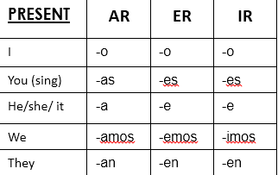
PRETERITE | AR | ER | IR
I | -é | -í | -í
You (sing) | -aste | -iste | -iste
He/she/ it | -ó | -ió | -ió
We | -amos | -imos | -imos
They | -aron | -ieron | -ieron

