Deberes – Write the correct initial (B, I, F, C) for each phrase.
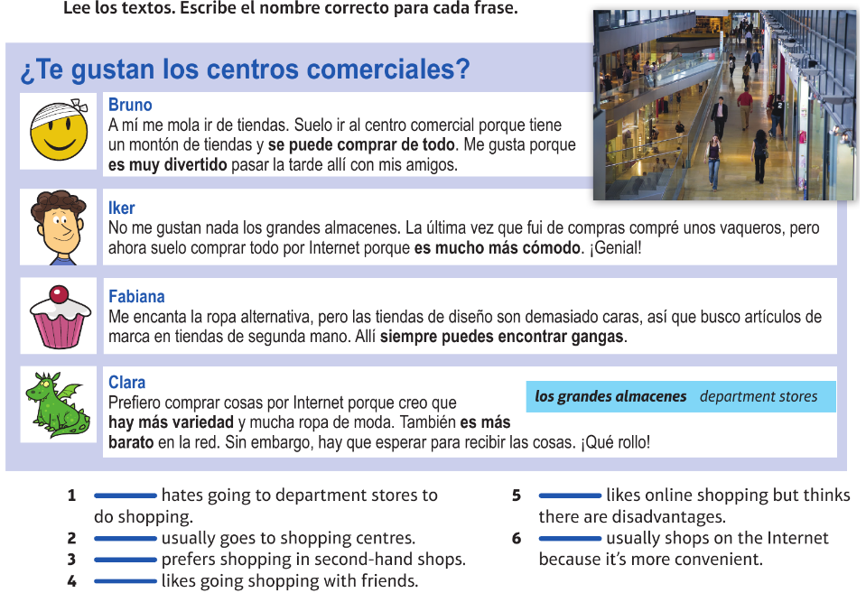

Deberes – Write the correct initial (B, I, F, C) for each phrase.

